**(MODULE – 5) DATABASE**

(Q.1) Create Table :

INSERT INTO `student`(rollnumber,`name`, `branch`) VALUES ('1','Jay','Computer Science'), ('2',’Suhani','Electronic and Communication'), ('3','Kriti','Electronic and Communication');

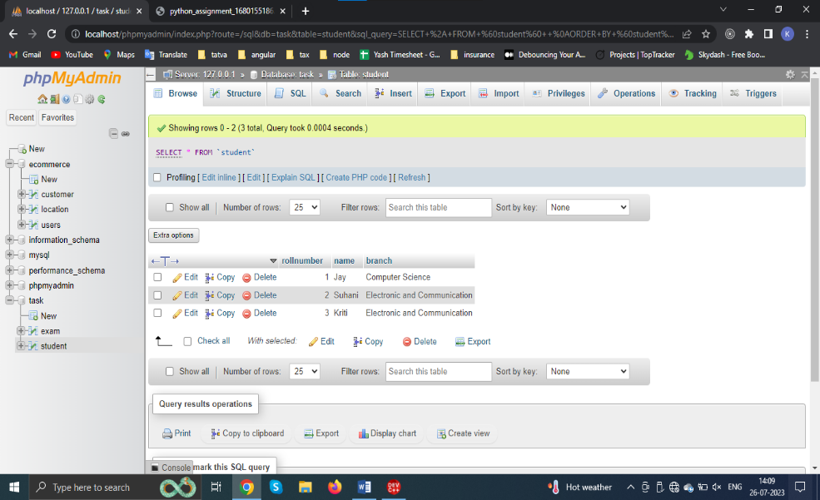

INSERT into exam(rollnumber,S_code,marks,P_code) VALUES ('1','CS11',50,'CS') ('1','CS12',60,'CS') ('2','EC101',66,'EC'),('2','EC102',70,'EC'),('3','EC101',45,'EC'),('3','EC102',50,'EC')

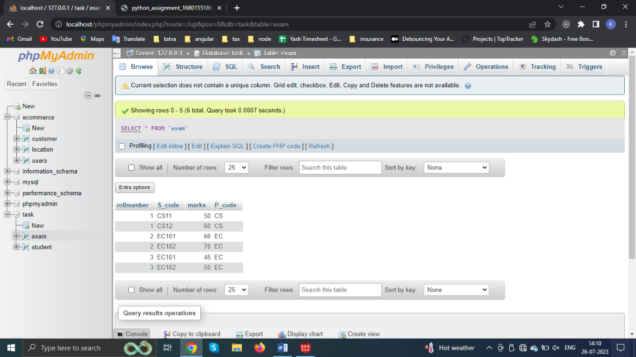

(Q.2) Create Table:

INSERT INTO users(Firstname,Lastname,Adress,City,Age) VALUES ('Mickey','Mouse','123,Fantasy Way','Anahiem',73),('Bat','Man','321, Carven Ave','Gotham',54),('Wonder','Woman','987, Turth Way','Paradise',39),('Donald','Duck','555, Quack Street','Mallard',65),('Bugs','Bunny','567, Carrot Street','Rascal',58),('Wiley','Coyote','999, Acme Way','Canyon',61),('Cat','Woman','234,Purrfect Street','Hairball',32),('Tweety','Bird','543','Itotitaw',28);

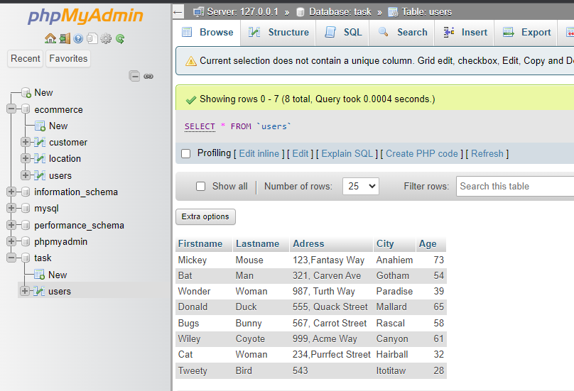

(Q.3) Create Table:

INSERT INTO employee (First_name, Last_name,Salary,Joining_date,Department) VALUES ('John','Abraham','1000000','2013-01-01 12.00.00','Banking'),('Micheal','Clarke','800000','2013-01-01 12.00.00','Insurance'),('Roy','Thomas','700000','2013-02-01 12.00.00','Banking'),('Tom','Jose','600000','2013-02-01 12.00.00','Insurance'),('Jerry','Pinto','650000','2013-02-01','Insurance'),('Philip','Mathew','750000','2013-01-01 12.00.00','Services'),('Testname1','123','650000','2013-01-01','Services'),('Testname2','Lname%',600000,'2013-02-01 12.00.00','Insurance');

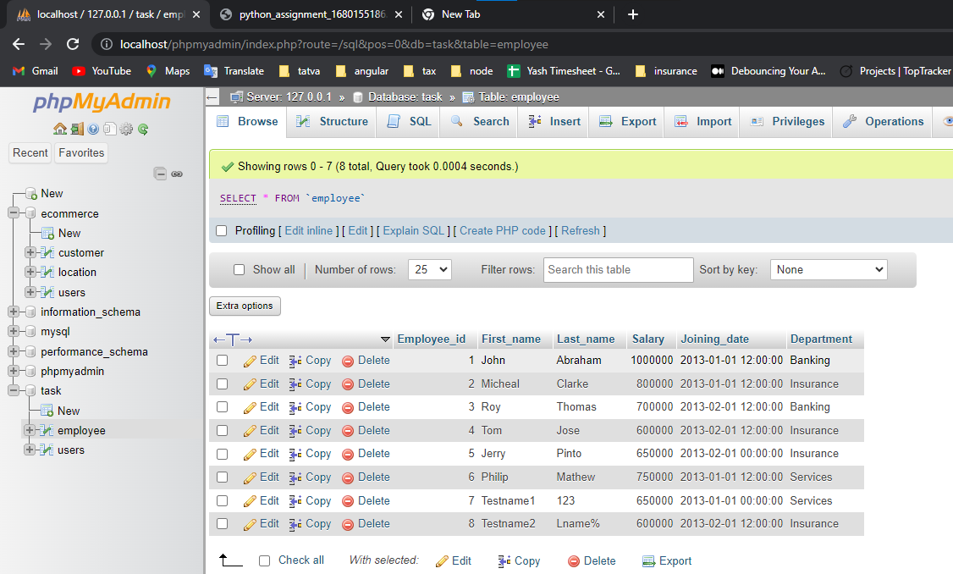

INSERT into incentive(Incentive_date,Incentive_amount) VALUES ('2013-02-01',5000),('2013-02-01',3000),('2013-02-01',4000),('2013-01-01',4500),('2013-01-01',3500);

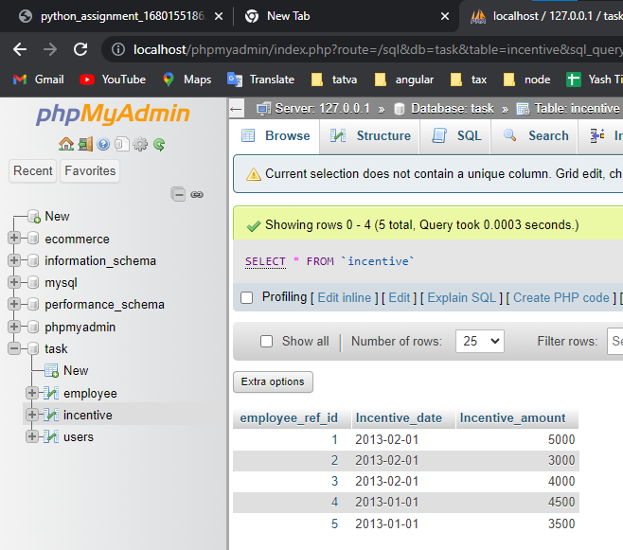

1. Get First_Name from employee table using Tom name “Employee Name”.

SELECT First_name FROM `employee`;

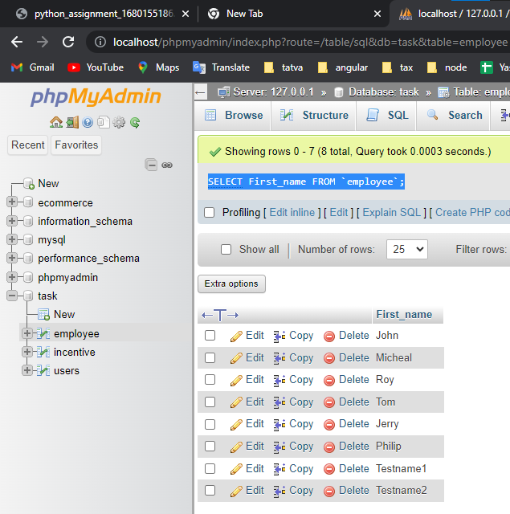

1. Get First_Name from employee table using Tom name “Employee Name”.

SELECT First_name,Salary,Joining_date from employee

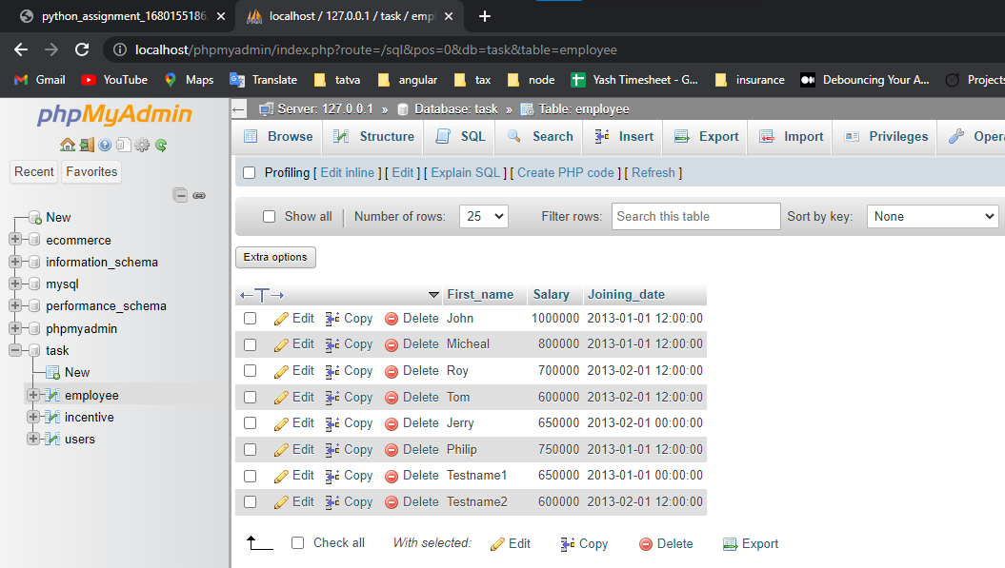

1. Get all employee details from the employee table order by First_Name Ascending and Salary descending?

SELECT * FROM `employee` ORDER BY First_name,Salary DESC;

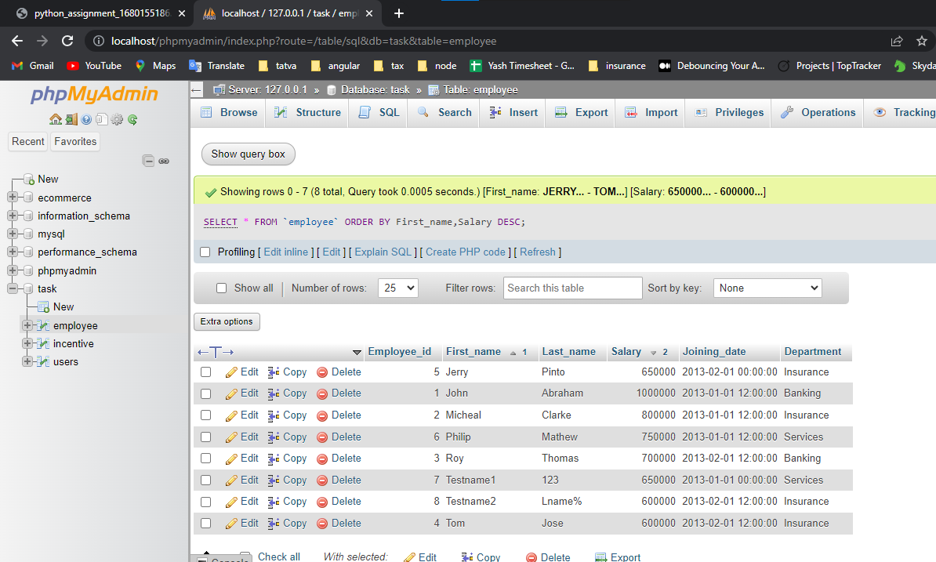

1. Get employee details from employee table whose first name contains ‘J’.

SELECT * FROM `employee` where First_name like "%J%";

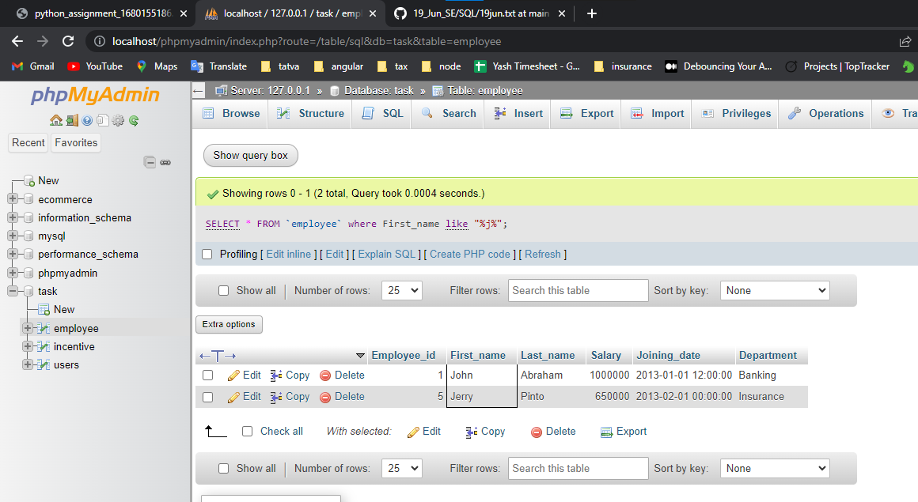

1. Get department wise maximum salary from employee table order by salary ascending?

SELECT MAX(Salary),First_name,Last_name as max_salary FROM `employee` GROUP BY Department order by Salary;

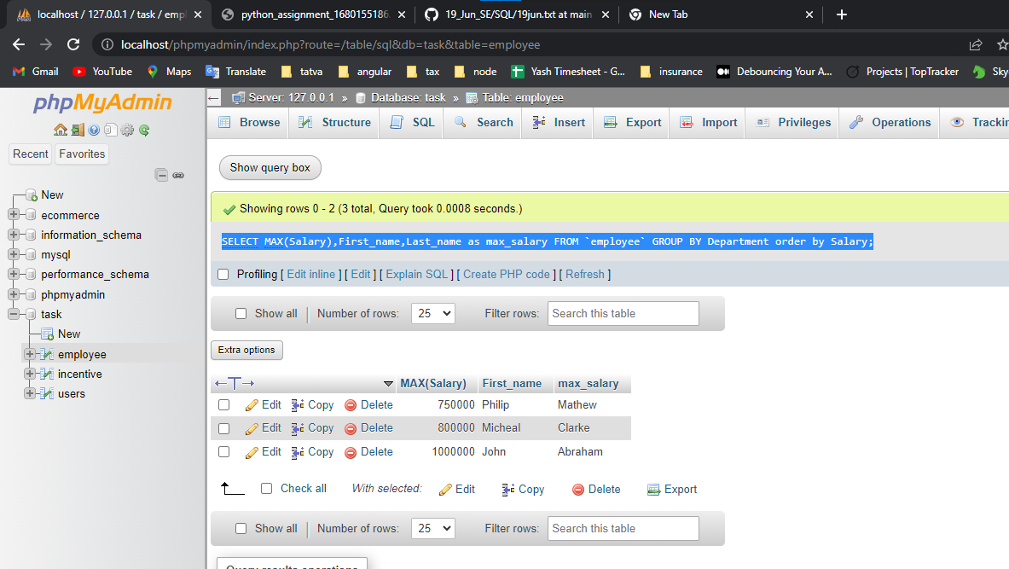

1. Select first_name, incentive amount from employee and incentives table for those employees who have incentives and incentive amount greater than 3000

SELECT employee.First_name, incentive.Incentive_amount FROM employee RIGHT JOIN incentive ON employee.Employee_id = incentive.employee_ref_id where incentive.Incentive_amount>3000;

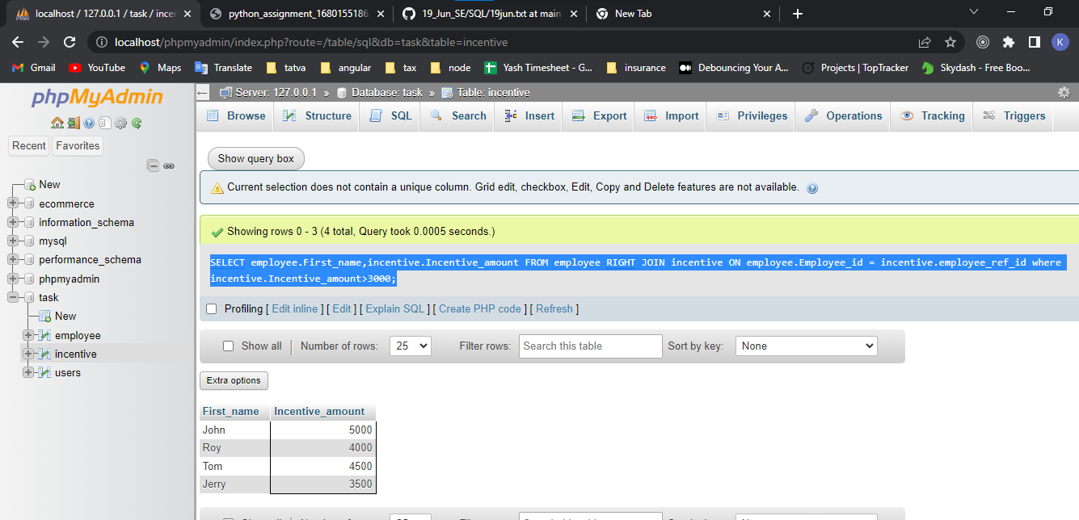

g) Create After Insert trigger on Employee table which insert records in view table

DELIMITER //

Create Trigger after_insert_details

AFTER INSERT ON employee FOR EACH ROW

BEGIN

INSERT INTO VIEWS VALUES (employee_id,First_name,Last_name,Salary,Joining_date,Department);

END //

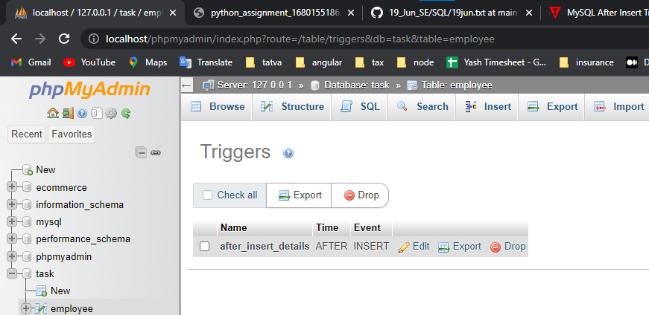

**(Q.4) Create table given below: Salesperson and Customer**

1. All orders for more than $1000.

SELECT * FROM customer where SNo>1000

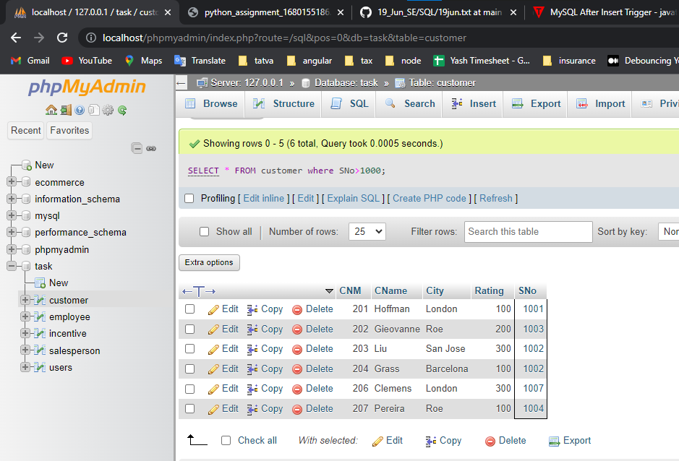

b) Names and cities of all salespeople in London with commission above 0.12

SELECT SName,City FROM `salesperson` WHERE COMM >0.12;

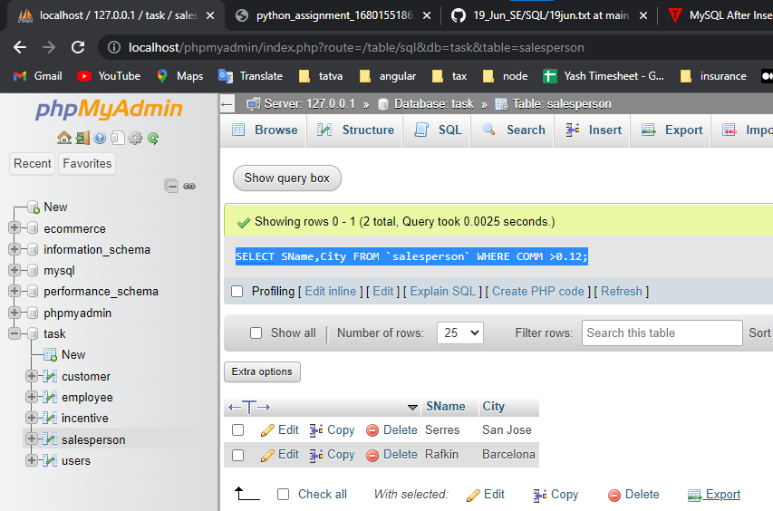

c) All salespeople either in Barcelona or in London

SELECT * FROM salesperson where City IN ("barcelona","london");

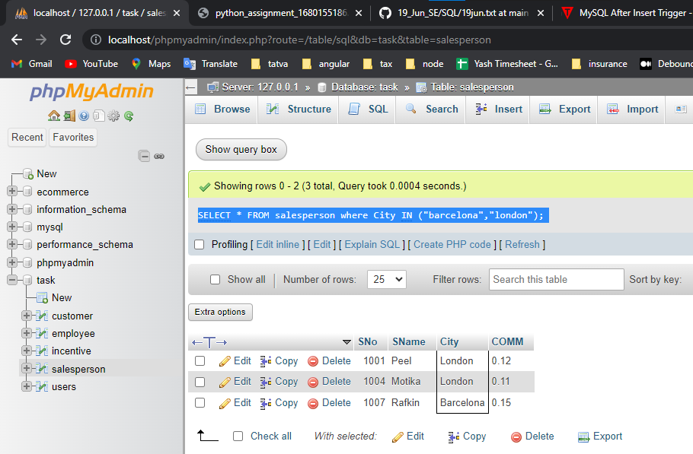

d) All salespeople with commission between 0.10 and 0.12. (Boundary values should be excluded).

SELECT * FROM salesperson where COMM NOT BETWEEN 0.12 and 0.15 AND COMM not in (0.1);

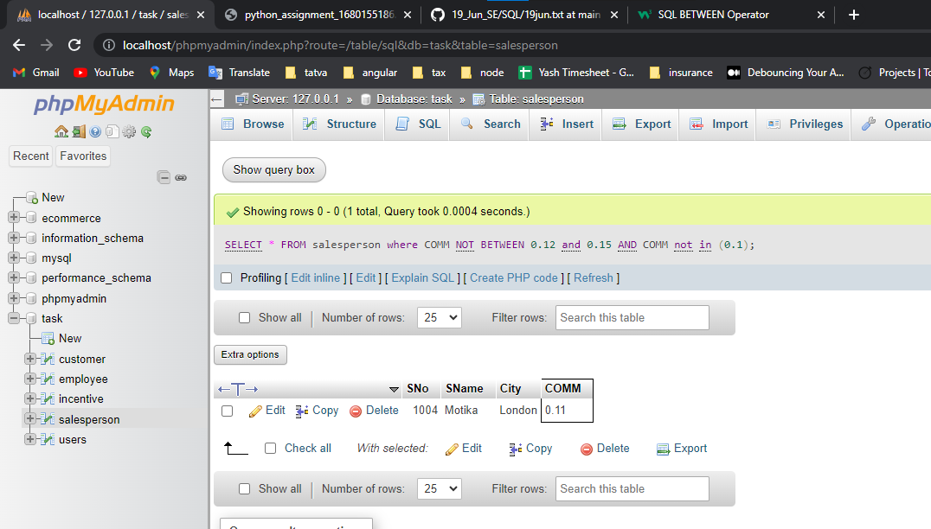

e) All customers excluding those with rating <= 100 unless they are located in Rome

SELECT * FROM `customer` WHERE Rating >100 OR City = 'rome'

